7. Files and Exceptions
When a program needs to save data for later use, it writes the data in a file. The data can be read from the file at a later time.
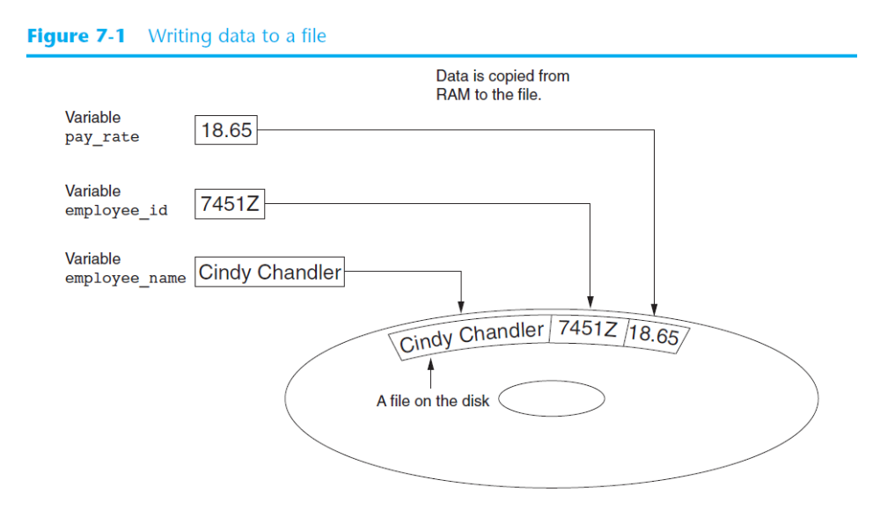

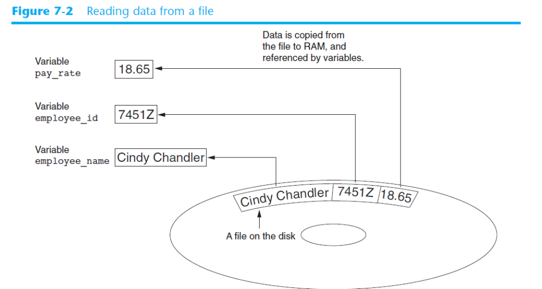
There are always three steps that must be taken when a file is used by a program.
1. Open the file—Opening a file creates a connection between the file and the program. Opening an output file usually creates the file on the disk and allows the program to write data to it. Opening an input file allows the program to read data from the file.
2. Process the file—In this step data is either written to the file (if it is an output file) or read from the file (if it is an input file).
3. Close the file—When the program is finished using the file, the file must be closed. Closing a file disconnects the file from the program.

Types of Files
In general, there are two types of files: text and binary. A text file contains data that has been encoded as text, using a scheme such as ASCII or Unicode. Even if the file contains numbers, those numbers are stored in the file as a series of characters. As a result, the file may be opened and viewed in a text editor such as Notepad. A binary file contains data that has not been converted to text. The data that is stored in a binary file is intended only for a program to read. As a consequence, you cannot view the contents of a binary file with a text editor.

File Access Methods

Most programming languages provide two different ways to access data stored in a file: sequential access and direct access. When you work with a sequential access file, you access data from the beginning of the file to the end of the file. If you want to read a piece of data that is stored at the very end of the file, you have to read all of the data that comes before it—you cannot jump directly to the desired data. When you work with a direct access file (which is also known as a random access file), you
can jump directly to any piece of data in the file without reading the data that comes before it. This is similar to the way a CD player or an MP3 player works. You can jump directly to any song that you want to listen to.

Filenames and File Objects

Most computer users are accustomed to the fact that files are identified by a filename. For example, when you create a document with a word processor and then save the document in a file, you have to specify a filename. When you use a utility such as Windows Explorer to examine the contents of your disk, you see a list of filenames

In order for a program to work with a file on the computer’s disk, the program must create a file object in memory. A file object is an object that is associated with a specific file and provides a way for the program to work with that file.

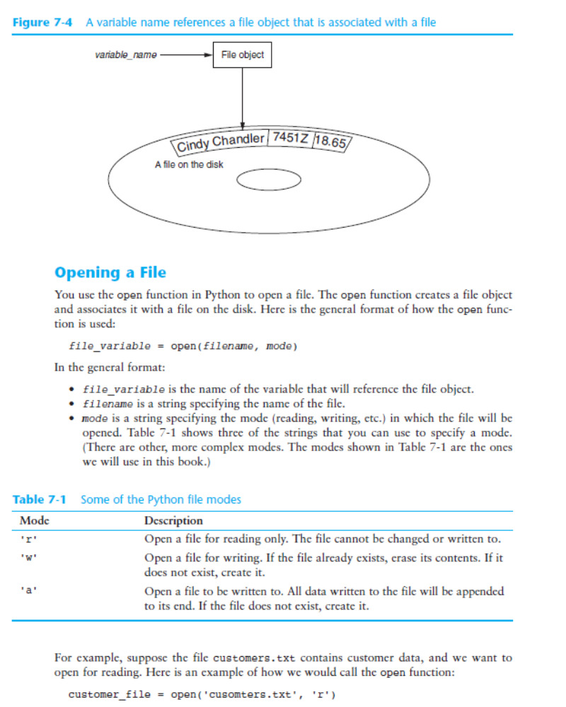

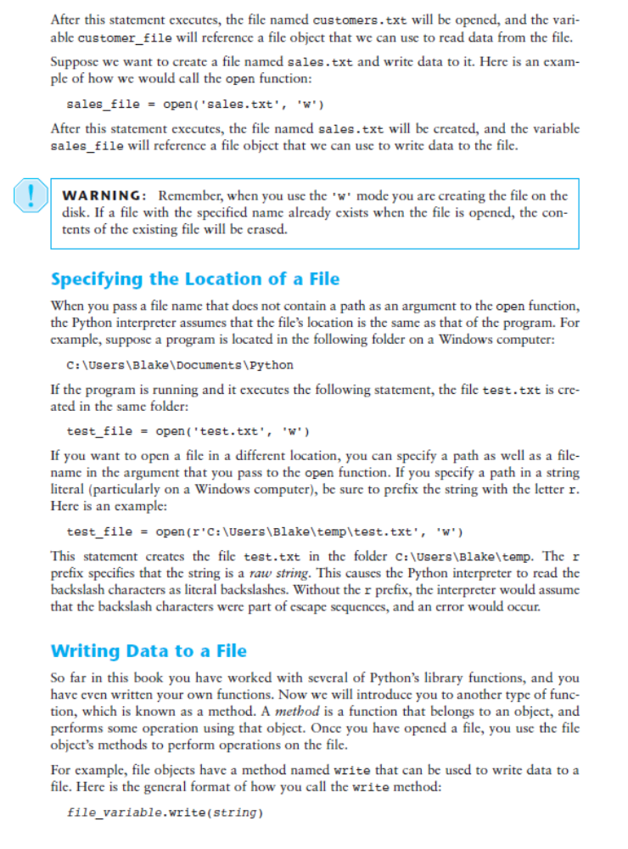

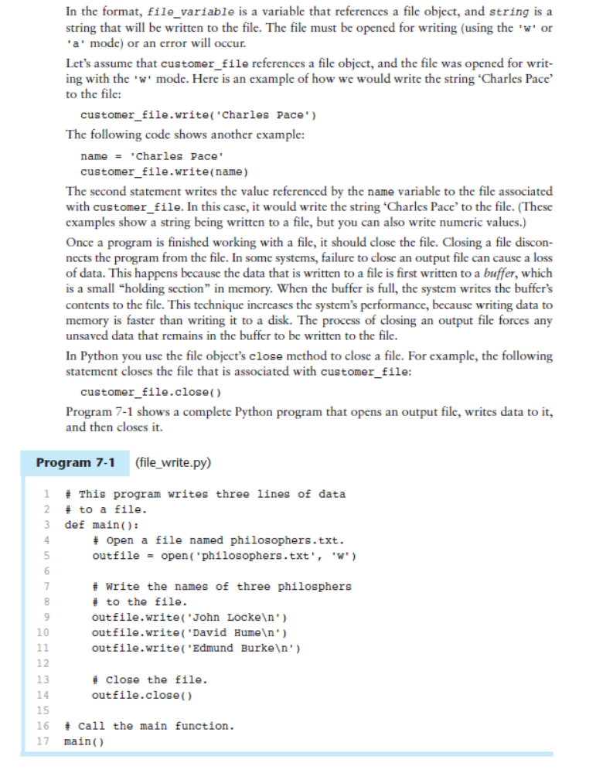

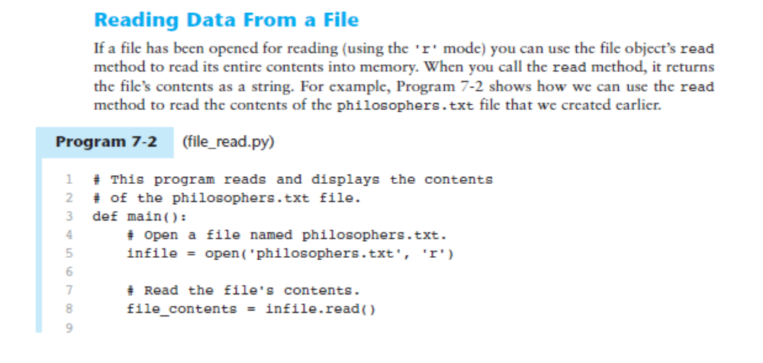
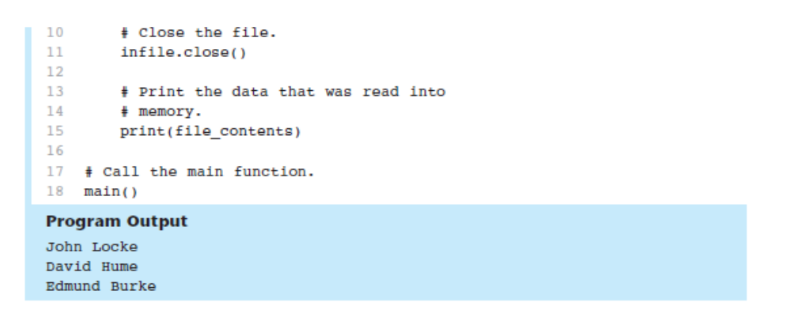

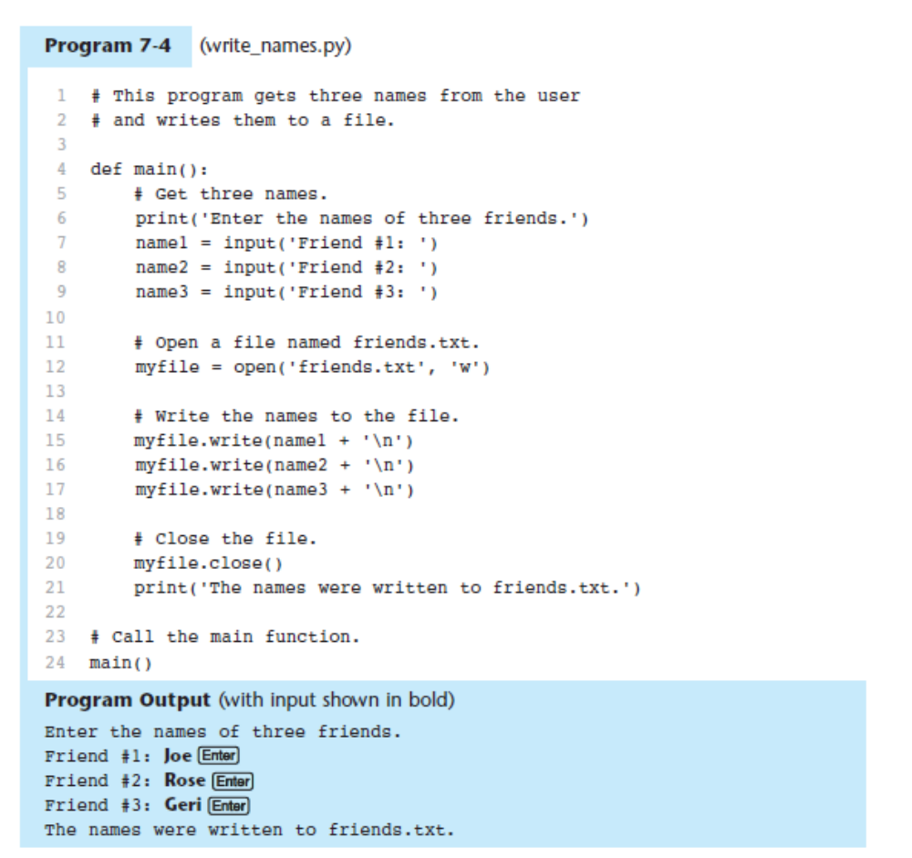
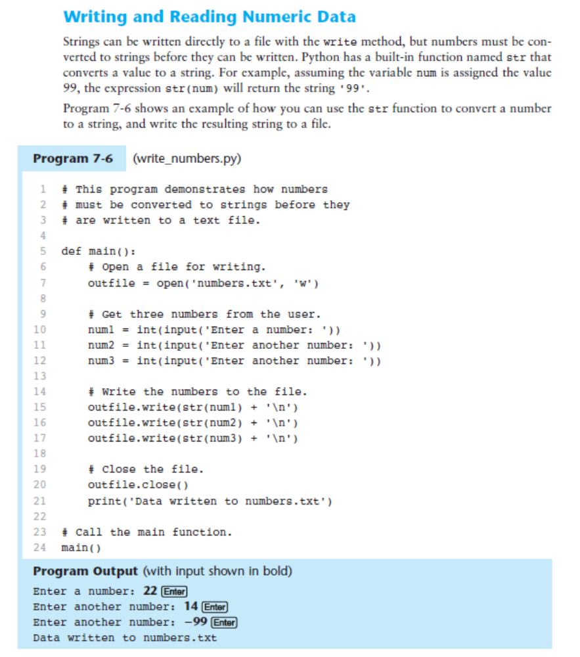

Using Python’s for Loop to Read Lines

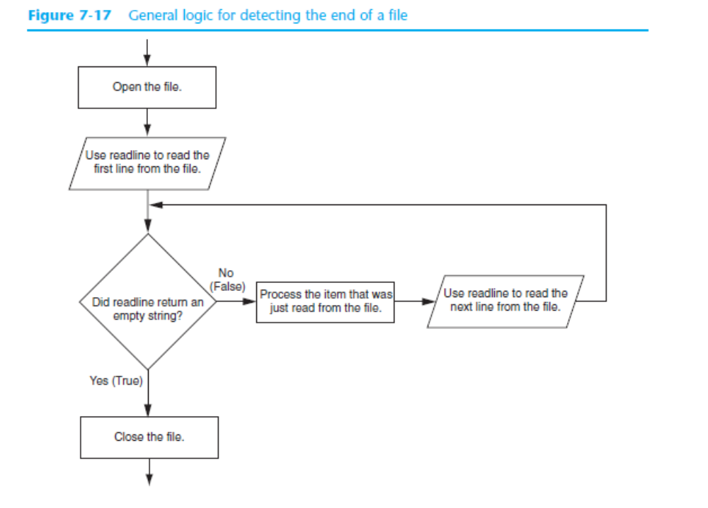

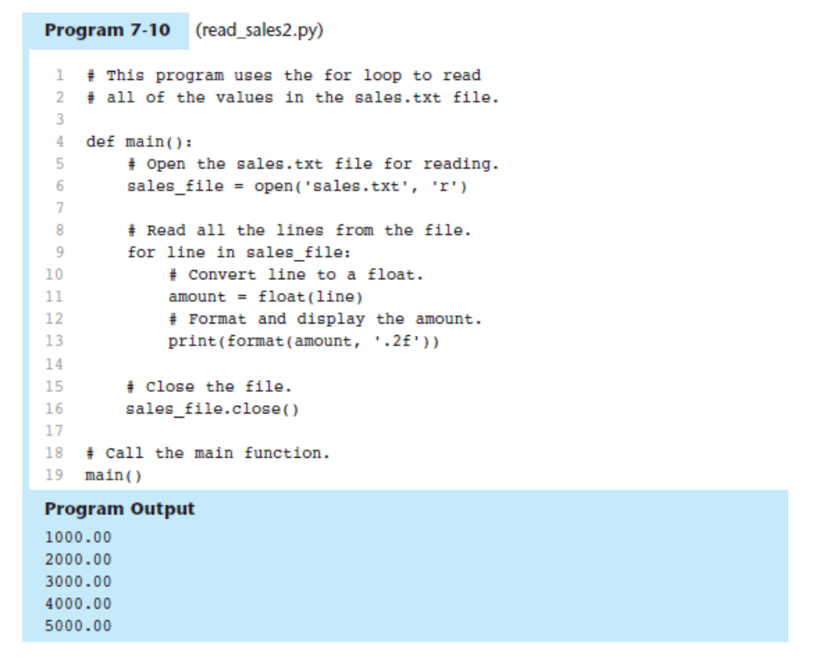

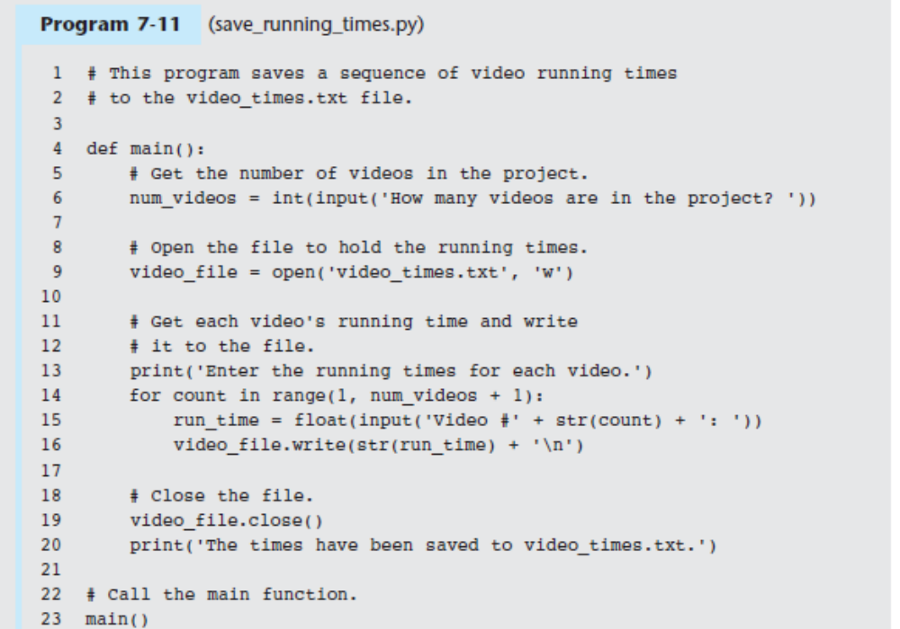

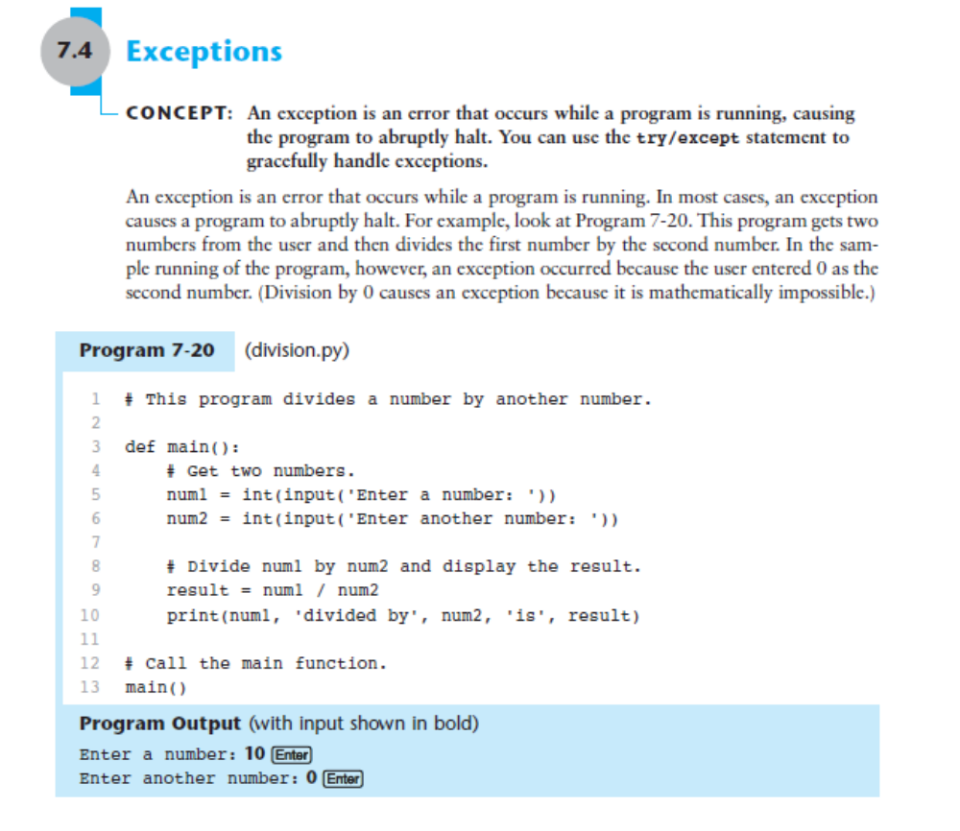
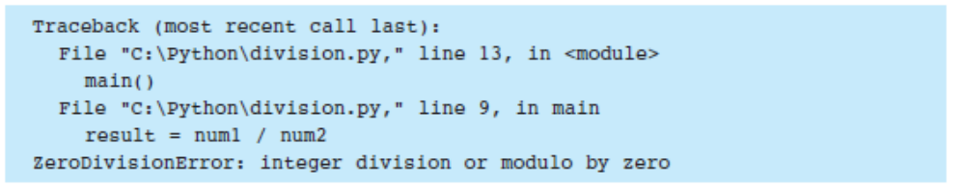

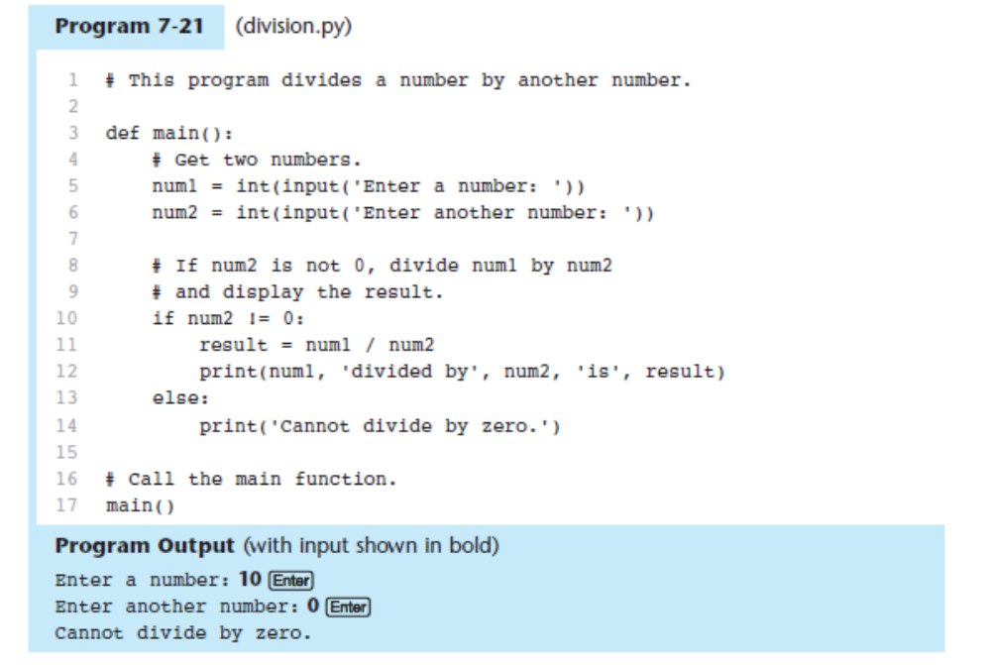

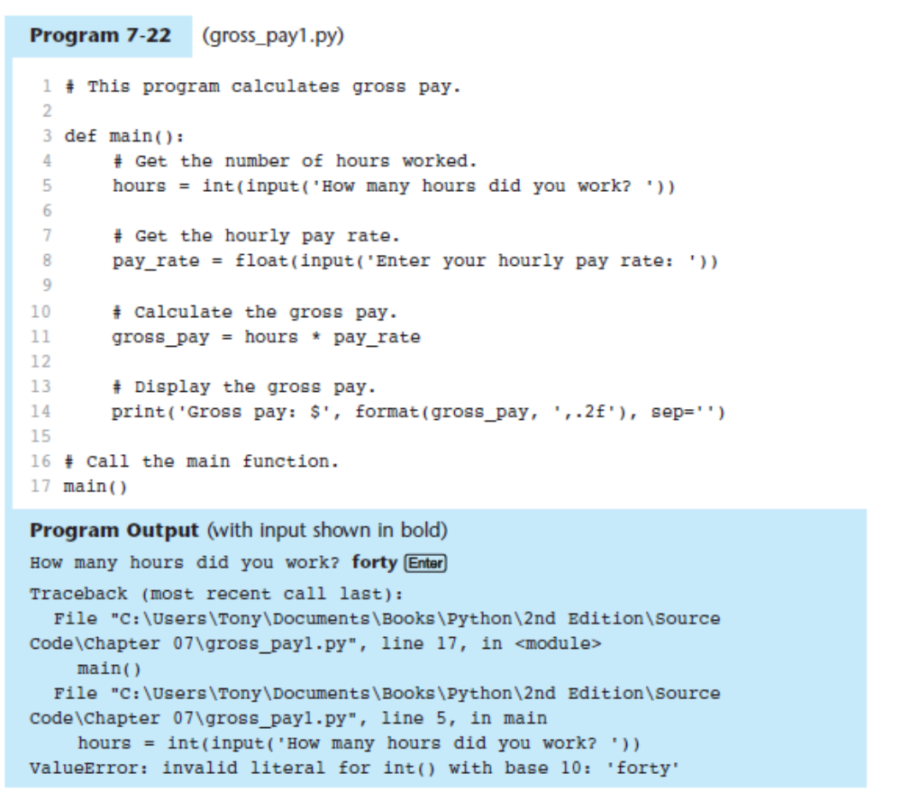

There
are several ways to write a try/except statement, but the following general format shows
the simplest variation:
try:
statement
statement
etc.
except ExceptionName:
statement
statement
etc.
First the key word try appears, followed by a colon. Next, a code block appears which we
will refer to as the try suite. The try suite is one or more statements that can potentially raise an exception. After the try suite, an except clause appears. The except clause begins with the key word except, optionally followed by the name of an exception, and ending with a colon. Beginning on the next line is a block of statements that we will refer to as a handler. When the try/except statement executes, the statements in the try suite begin to execute.
The following describes what happens next:
• If a statement in the try suite raises an exception that is specified by the ExceptionName in an except clause, then the handler that immediately follows the except clause executes. Then, the program resumes execution with the statement immediately following the try/except statement.
• If a statement in the try suite raises an exception that is not specified by the ExceptionName in an except clause, then the program will halt with a traceback error message.
• If the statements in the try suite execute without raising an exception, then any
except clauses and handlers in the statement are skipped and the program resumes

